**CHAPTER 1**

**INTRODUCTION**

* 1. **Project Overview**

Barcode is a visual depiction of information in the form of bars and spaces on a surface. The bars and spaces and be of different widths and consists of numbers, characters and symbols such as dot, colon and others. Different combinations of these alphanumeric characters are used to depict information. There are various types of barcodes in use today. These include Code 128, Code 39, EAN etc.

The successful barcode technology has been constantly improving in order to accommodate more information in the least possible space. Today barcodes are widely used on books and at retail stores in order to keep track of the products available and easy checkout of the products. The barcodes are read using scanners, using laser beams or cameras.

“This project is to develop an algorithm of barcode recognition system by using web camera or digital camera or image from any folder then display the barcode information for the user.”

Nowadays most of the barcode scanners are using infrared methods to scan a barcode. This may lead to the cost issue where those scanners are expensive and unaffordable to the user. To overcome this problem, the camera based system for barcode reading is applied to develop a barcode recognition system.

* 1. **Decoders or Scanners**
  + A device used to extract information optically from a Bar Code
  + Bar Code symbol consists of series of vertical dark bars separated by spaces
  + When illuminated reflected light is detected by electro optical sensor
  + The intensity of reflected light from the dark bars is less than that of spaces
  + Reflected light is converted into electrical voltage signals
  + Analog voltages are digitized into raw data
  + The decoder converts this data into the character data representation of the symbol’s code
    1. **Types of Decoders/Scanners**

There are three basic types of barcode scanning device.

**1.2.1.1 Contacts wands**

Must touch or come in close proximity of symbol.

Good where the label cannot be placed in an easy-to-view position

Normally hand-held/stationary units

Common type is pen/wand reader

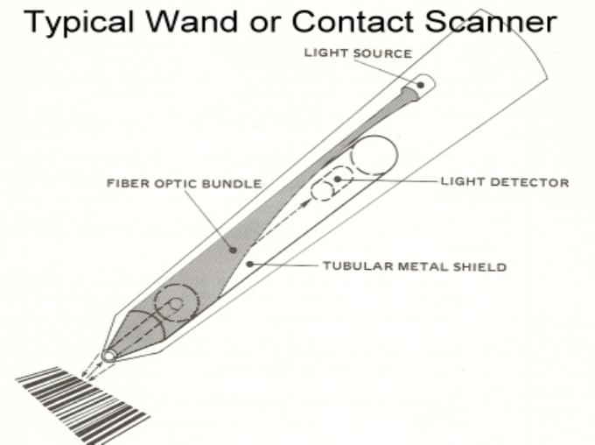Positioned angle of wand to the surface and movement speed across the symbol are key parameters

**Note: Non Contact Readers:**

* Readers not need to come in contact with symbol.
* Scan Distance may be from 6 to several feet depending upon symbol size & scanner design.
* Hand held fixed beam readers.

**1.2.1.2 Active Non-Contact Readers**

The use of helium-neon gas lasers as a light source revolutionized non-contact bar code reading.

Scanning bar code labels at a distance required labels made from retro reflective material consisting of thousands of microscopic glass beads. It is im-practical due to high price.

Because of the rapid scanning speed, the narrow beam of a laser scanner appears as a continuous line or geometric figure.

Active non-contact laser scanners may be found in fixed or handheld units

**1.2.1.2.1 FIXED SCANNERS**

Projects an omni-directional pattern.

Used for hands-free scaning.

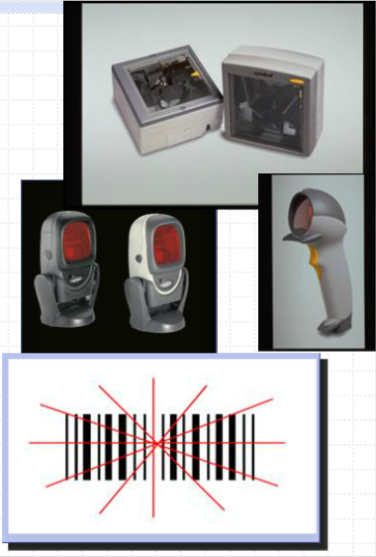

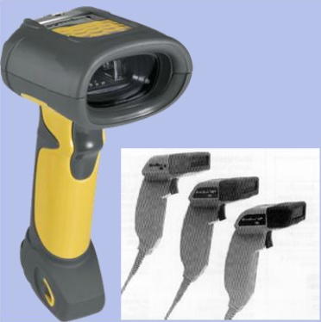**1.2.1.2.2 Laser Scanner**

Improved depth of field.

Standard range: 6 to 24 inches.

Long range: 2 to 9 feet.

Extra long range 3 to 30 field.

Very aggressive.

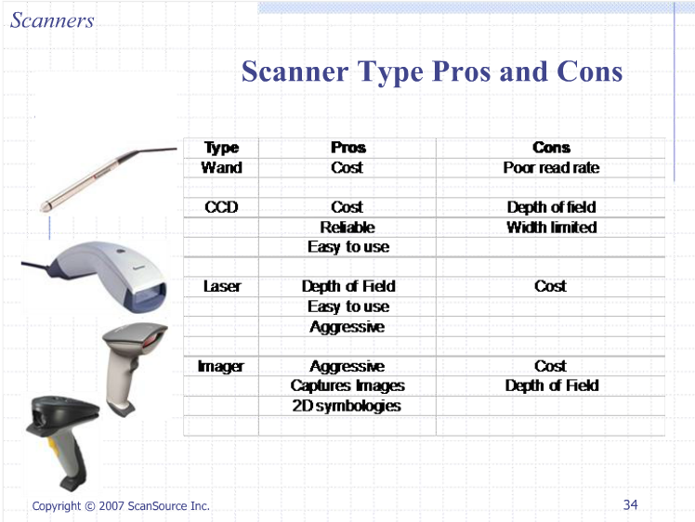

**1.2.1.3 Passive Non-contacts Readers**

Passive non-contacts operates like a video camera.

The bar code label is illuminated by a light source in the reader.

Electric charge was passed, then the light was put on the exact barcode, the black area don’t reflects anything while the white area is reflected.

The field of view of passive scanners is limited, so they can not read long barcodes.

Uses charge couple device. (CCD)

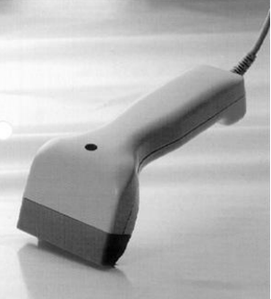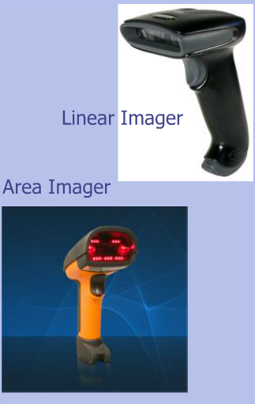

**1.3 Project Objectives**

**i**. To develop a barcode recognition system by using MATLAB programming code and image processing.

**ii**. To design a barcode system that can read UPC-A barcode.

**iii.** To design another alternative way of reading barcode with the lowest cost and effective.

**1.4 Problem Statement**

Usually, data from barcode can only be read with the barcode scanner. There is no other device or method that capable to read barcode thus, this project is proposed to be an additional method for barcode reading by using image processing.

The image processing module comprises an image-preprocessing module that transforms the camera-captured image or any image from file or folder into a preprocessed grayscale image, reduces noise in the preprocessed image, and enhances contrast between bars and spaces in the preprocessed image.

So it is hard for user who is interested with the barcode system usually hard to find cheapest way to learn about the barcode because of the high price barcode scanner. This is due to the high price for an electronics scanner in the markets.

**1.5 Project Scope**

Research and find information about the image processing, barcode type, barcode applications and all related calculations. For the image-processing module comprises an image-preprocessing module that transforms the camera-captured image into a preprocessed grayscale image, reduces noise in the preprocessed image, and enhances contrast between bars and spaces in the preprocessed image.

Design program by using MATLAB. The Image Processing Toolbox extends the basic capabilities of MATLAB, by providing a number of specialized I/O, display, and processing functions for images and image processing.

**1.6 Project Methodolog**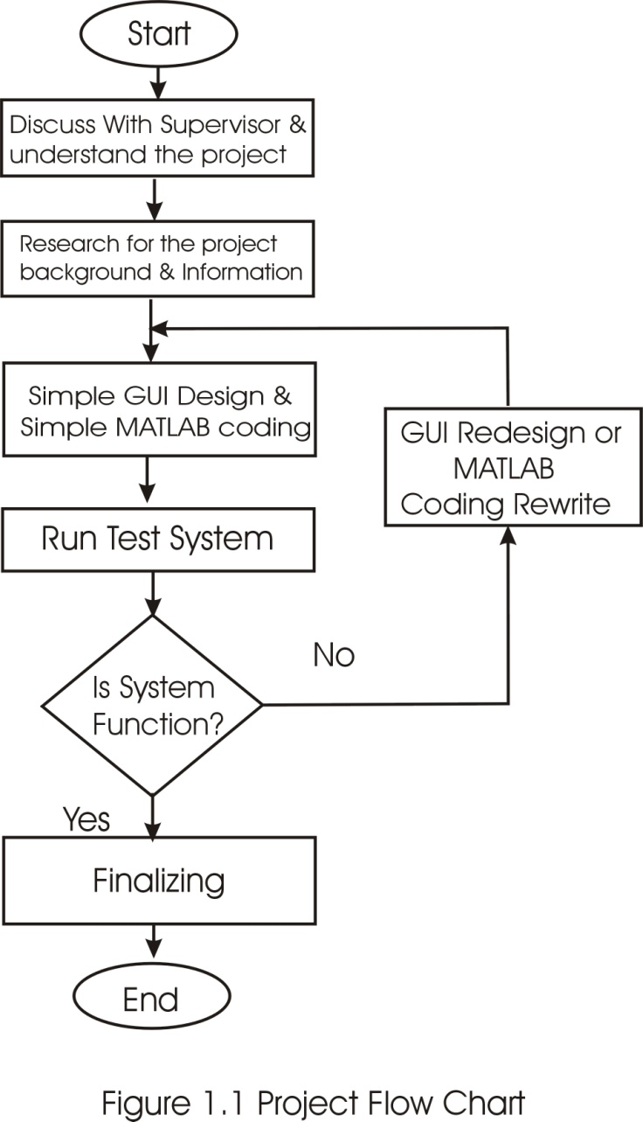

**1.7 Flowchart Explanation:**

**i.** D**iscussion with supervisor and understand the project concept.**

Found that this project was related with barcode and image processing.

**ii.** D**iscussed with supervisor and understand the concept of project**.

Project was about barcode reading but using image processing method to extract data from barcode.

**iii. Do research background and information of the project.**

Search for the barcode system information and how the data is read out from the barcode.

**iv. Simple GUI design and write simple MATLAB coding.**

Design the GUI by using MATLAB GUI for the barcode and image processing

user interface and write MATLAB coding.

**v. GUI redesign or MATLAB coding rewrite.**

Observe system functionality whether system function as it should be or

otherwise system need to be redesign or program debugging.

**vi. Finalizing.**

Being well prepared for the presentation and make sure all tools and materials require for the presentation are prepared before the presentation day.